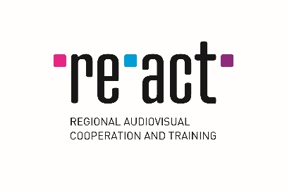
RE-ACT Co-development Funding

APPLICATION FORM
Deadline: 15 November 2019
Please complete this form and send it together with other requested documents to: info@filmreact.eu

Date
Delegate producer (first & last name)
Nationality
Production company
Position in the company
Address
City
Country
E-mail (will be used for all communication)
Phone number
Title of the project in English
Original title of the project
Genre (fiction, documentary or animation)
Name of the director
Name of the scriptwriter
Estimated duration of the project (in minutes)
Co-producer 1 – country and company name
Co-producer 2 – country and company name
Additional co-producer (if existed) – country and company name

Application documents to be sent in English (each document as a separate word/pdf document):

For fiction and documentaries (use boxes below as a checklist to mark the document (X) you are attaching):

FICTION  AND  DOCUMENTARIES | This application form, completed (as a word document)
 | 1 page Synopsis
 | 8-10 pages Treatment
 | 1 page note of intention of the director
 | Profile of the producer, director and scriptwriter
 | Production company profile
 | Development financing plan in Euros
 | Development budget in Euros
 | Co-development agreement(s) or deal-memo(s) between the co-producers
 | Evidence of already secured financing

For animation films (use boxes below as a checklist to mark the document (X) you are attaching):

ANIMATIONS | This application form, completed (as a word document)
 | Synopsis or treatment with visuals
 | 1 page note of intention of the director
 | Profile of the producer, director and scriptwriter
 | Production company profile
 | Development financing plan in Euros
 | Development budget in Euros
 | Co-development agreement(s) or deal-memo(s) between the co-producers
 | Evidence of already secured financing

Use the box below
to fill in (x)
I have read and understood Guidelines for Co-development Funding (Guidelines)
I am a person authorised by co-producers to submit this application and I am enclosing a documentary evidence to that effect (authorisation letter signed by all co-producers)

